Multimodal Emotion Recognition
Using Speech and Text Modalities - by parinita

A. Architecture Decisions

Overall System Architecture
The proposed emotion recognition system adopts a multimodal deep learning architecture that integrates speech and text signals for comprehensive emotional analysis. The system comprises three parallel pipelines that operate either independently or in fusion:
- Speech-only Emotion Recognition Pipeline
- Text-only Emotion Recognition Pipeline
- Multimodal Fusion System (Speech + Text)

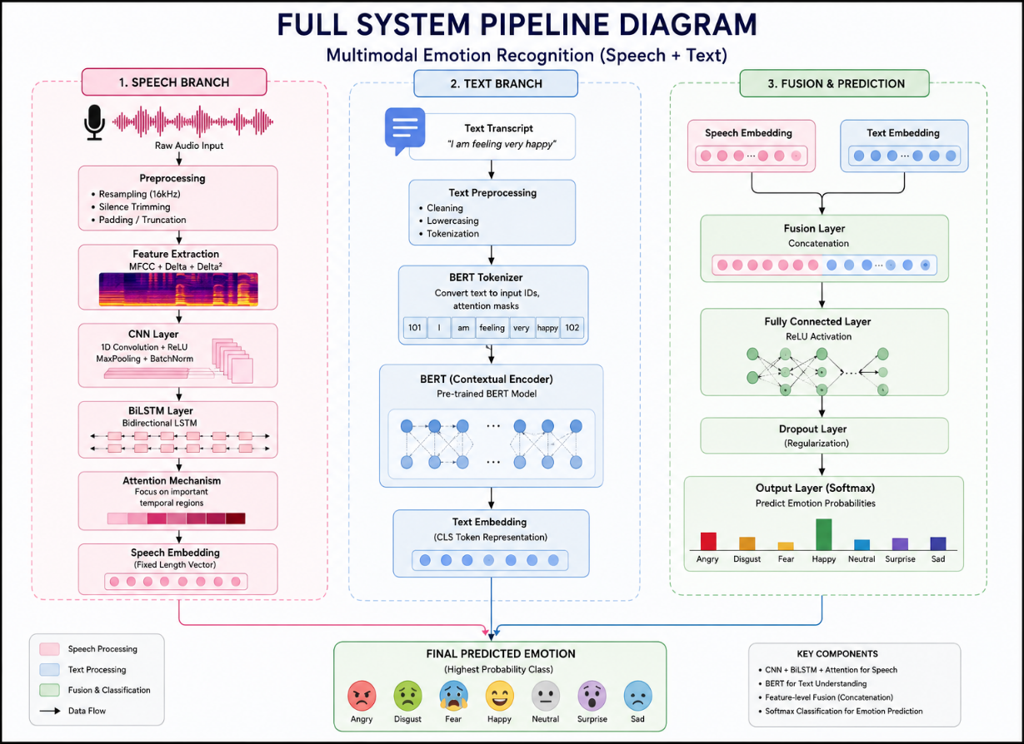

Figure 1: Complete Multimodal Emotion Recognition Pipeline

1. Preprocessing Block

A) Speech Preprocessing
Architecture / Method Used
- Librosa audio preprocessing
- Silence trimming
- Padding / Truncation to fixed length
- Fixed sampling rate (16 kHz)
Why Was It Chosen?
Speech recordings in the TESS dataset exhibit varying silence regions, variable durations, and inconsistent waveform lengths. Deep learning models require fixed-size numerical input; therefore:
- Silence trimming removes irrelevant non-emotional regions
- Fixed sampling rate standardises audio quality across all recordings
- Padding ensures equal temporal dimensions for batch processing
Implementation
librosa.effects.trim() · sr = 16000 · np.pad()
Why It Helps Emotion Recognition
Emotional information predominantly resides in pitch variation, intensity, and temporal speech dynamics. Removing silence enables the model to focus exclusively on emotionally informative speech segments, improving both training efficiency and classification accuracy.

B) Text Preprocessing
Method Used
- Text cleaning and normalisation
- Tokenisation
- BERT Tokenizer
Why Was It Chosen?
Neural language models cannot process raw text directly. The BERT tokenizer converts words into token IDs while preserving sentence structure, semantic meaning, and contextual information. This enables the downstream BERT encoder to generate rich, context-aware text representations suitable for emotion classification.
Implementation
BertTokenizer.from_pretrained('bert-base-uncased')

2. Feature Extraction Block

A) Speech Feature Extraction — MFCC + Δ + Δ²
Why MFCC?
Mel Frequency Cepstral Coefficients (MFCCs) are the standard feature representation in speech processing. They capture the spectral characteristics of human speech and closely mimic the non-linear auditory perception of the human ear, making them highly effective for emotion-related vocal analysis.
Why Delta Features (Δ)?
Emotion is inherently dynamic — it evolves over the course of an utterance. Delta features capture the rate of spectral change over time, which is critical for detecting emotions such as excitement, anger, and sadness that are characterised by specific temporal transitions.
Why Delta-Delta Features (Δ²)?
Delta-Delta features capture the acceleration of speech dynamics, providing a second-order temporal representation. This further improves emotional temporal modelling and adds robustness to speaking-rate variations across speakers.
Final Speech Representation
The speech feature map is a 120-dimensional representation constructed from 40 MFCC coefficients, 40 Delta coefficients, and 40 Delta-Delta coefficients, forming a rich acoustic fingerprint of each utterance.
Implementation
librosa.feature.mfcc() · librosa.feature.delta()

B) Text Feature Extraction — BERT Embeddings
Why BERT?
Traditional word embeddings such as Word2Vec and GloVe generate static word representations — the same word always receives the same vector regardless of context. BERT (Bidirectional Encoder Representations from Transformers) generates contextual embeddings, where the same word can receive different representations depending on the surrounding sentence. This is critically important for emotion recognition because the emotional meaning of a word is highly context-dependent.
Why Important for Emotion Recognition?
Emotion in text depends heavily on semantics, context, and linguistic nuance. BERT captures semantic relationships, contextual meaning, and sentence-level understanding far better than traditional NLP methods, enabling more reliable emotion inference from textual transcripts.
Implementation
BertModel.from_pretrained('bert-base-uncased')

3. Temporal / Contextual Modelling Block

A) Speech Temporal Modelling — CNN + BiLSTM + Attention
Why CNN?
Convolutional Neural Networks extract local acoustic patterns from the MFCC feature maps. These include pitch bursts, frequency changes, and other short-range local emotional cues embedded within the spectral representation of speech.
Why BiLSTM?
Emotion evolves over the duration of an utterance and cannot be assessed from a single frame in isolation. A Bidirectional Long Short-Term Memory (BiLSTM) network learns long-term temporal dependencies by processing speech both forwards and backwards in time. This bidirectional processing significantly improves emotional sequence understanding and contextual acoustic modelling.
Why Attention?
Not all speech frames carry equal emotional information. The attention mechanism allows the model to selectively focus on the most emotionally salient regions of an utterance, rather than treating all temporal frames uniformly. This improves interpretability, discriminative learning, and emotion separability between classes.
Implementation
nn.Conv1d() · nn.LSTM(bidirectional=True) · Attention()

B) Text Contextual Modelling — BERT Transformer Encoder

Why Transformer-based Contextual Modelling?
Transformer architectures capture long-range dependencies and contextual semantics far more effectively than recurrent approaches such as RNN, LSTM, or GRU. The self-attention mechanism in BERT enables every token to attend to all other tokens simultaneously, producing rich, globally-informed representations.
Why Suitable for Emotion Recognition?
Emotion recognition from text fundamentally requires deep semantic understanding. BERT enables contextual reasoning, richer language representation, and improved emotional interpretation compared to traditional sequence models. This makes it the optimal choice for encoding textual transcripts in the emotion recognition framework.

4. Fusion Block — Feature-level Concatenation

Why Fusion?
Speech captures the acoustic dimension of emotion tone, pitch, intensity, and temporal dynamics. Text captures the semantic dimension the linguistic meaning and context of what is said. Combining both modalities provides complementary emotional information that neither modality can supply alone, resulting in a more robust and comprehensive emotion recognition system.
Why Concatenation Fusion?
Feature-level concatenation is a simple, effective, and computationally efficient fusion strategy. By directly concatenating the speech embedding with the text embedding, the method preserves the complete representation from each modality without losing any modality-specific information. This avoids the information loss that can occur with more aggressive fusion methods such as weighted averaging or gating.

Implementation
torch.cat([speech_embedding, text_embedding], dim=-1)

5. Classifier Block — Dense Neural Network + Softmax

Why Dense Layers?
Fully connected dense layers learn non-linear relationships among the extracted features, combine the multimodal representations into a unified decision space, and ultimately map the fused embeddings to the target emotion classes.
Why Softmax?
Emotion recognition is a multi-class classification problem. The Softmax activation function converts the raw output logits into a calibrated probability distribution across all emotion classes, enabling the model to assign a confidence score to each predicted emotion.

Output Emotion Classes
# | Emotion Class
1 | Angry
2 | Disgust
3 | Fear
4 | Happy
5 | Neutral
6 | Pleasant Surprise
7 | Sad

Final Architectural Justification

The proposed architecture was selected because it effectively combines acoustic feature learning, temporal sequence modelling, contextual semantic understanding, and multimodal representation learning into a unified emotion recognition framework. For speech processing, the CNN–BiLSTM–Attention architecture was adopted to capture local acoustic patterns, temporal dependencies, and emotionally relevant regions within speech signals. For text processing, BERT was used to generate contextual text representations that encode semantic information from transcripts. Feature-level concatenation fusion was applied to integrate speech and text representations while preserving modality-specific characteristics. Finally, a dense classification layer maps the learned multimodal representation to emotion probabilities for final prediction.

B. Experiments

Speech-only, Text-only, Multimodal Comparison

1. Experimental Setup

Dataset
Toronto Emotional Speech Set (TESS)
Emotion Classes
- Angry
- Disgust
- Fear
- Happy
- Neutral
- Pleasant Surprise
- Sad
Train-Test Split
- 80% Training
- 20% Testing
Hardware / Software Configuration
Component | Details
Language | Python
Framework | PyTorch
Audio Library | Librosa
NLP Library | HuggingFace Transformers
UI | Streamlit

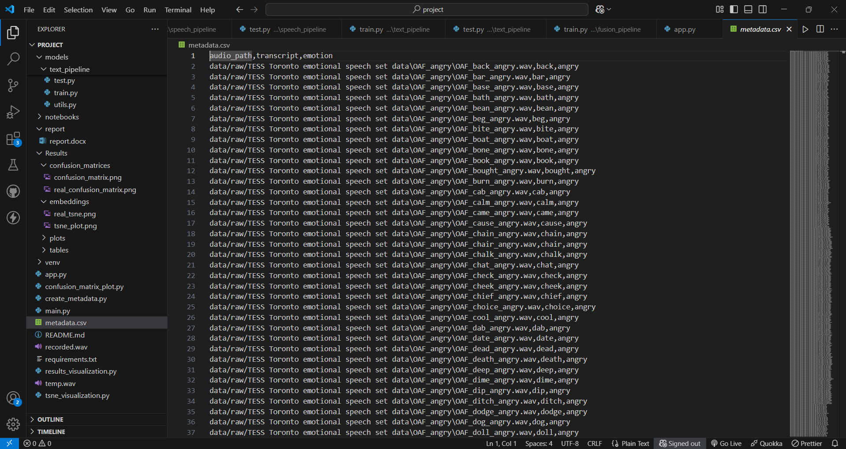
Figure B-1: Dataset Sample — TESS Metadata

2. Speech-only Model Experiment

Architecture Used
MFCC + CNN + BiLSTM + Attention
Objective
To classify emotions using speech signals only, evaluating the standalone performance of the acoustic modelling pipeline.
Observations
The speech-only model achieved extremely high accuracy because emotional information in the TESS dataset is strongly represented through vocal characteristics such as pitch, intensity, and temporal speech dynamics. The CNN effectively captured local acoustic patterns while the BiLSTM learned long-range temporal dependencies. The attention mechanism further enhanced discrimination by focusing on the most emotionally salient speech frames.
Results
Metric | Value
Train Accuracy | 100%
Test Accuracy | 99.8 – 100%

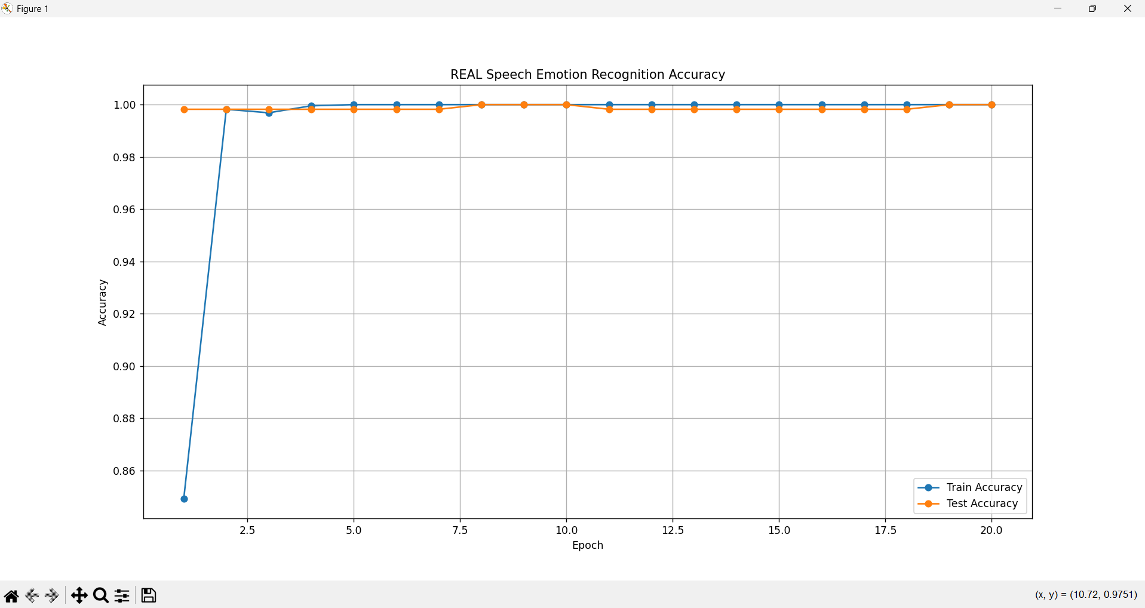
Figure B-2: Speech-only Model — Training & Validation Accuracy
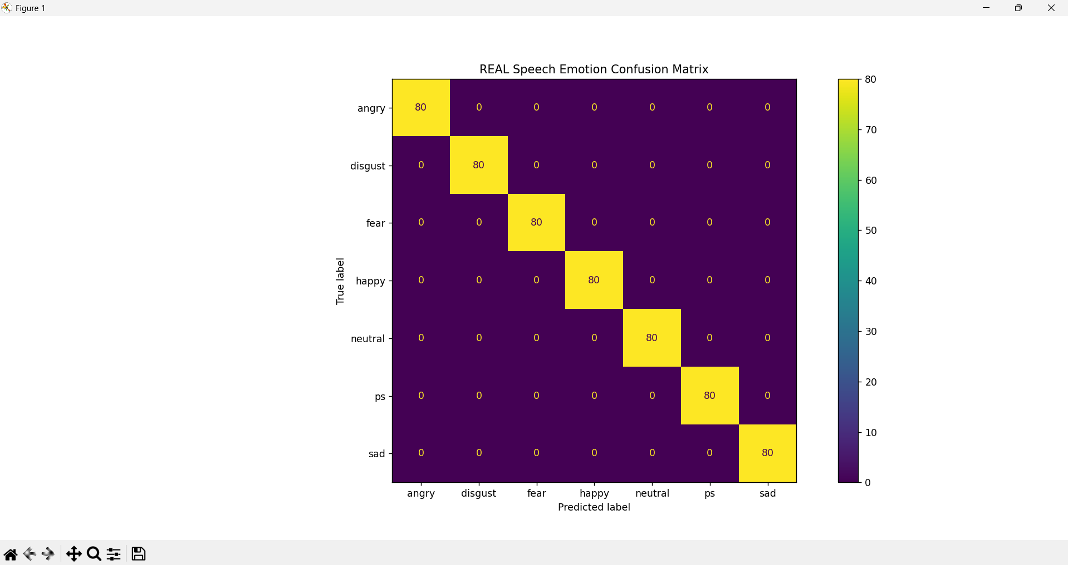
Figure B-3: Speech-only Model — Confusion Matrix
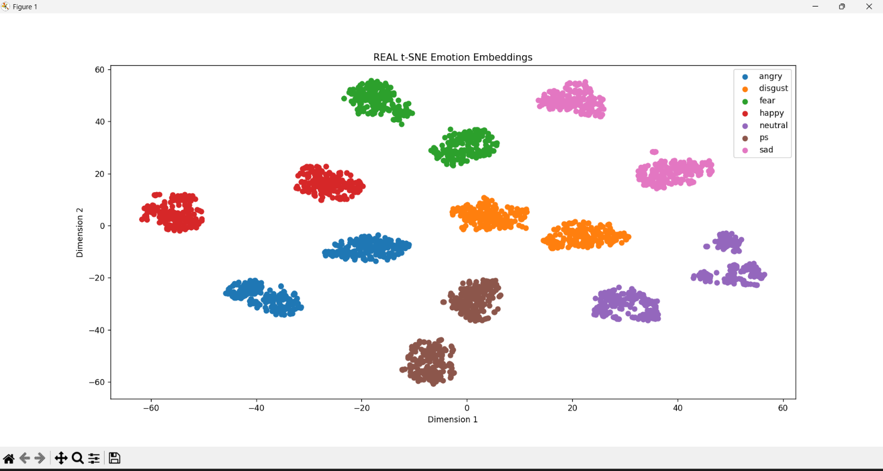
Figure B-4: Speech-only Model — t-SNE Embedding Visualisation

3. Text-only Model Experiment

Architecture Used
BERT-based Text Classification
Objective
To classify emotions using text transcripts only, evaluating the standalone performance of the semantic language modelling pipeline.
Observations
The text-only model achieved lower accuracy compared to the speech-only model because the TESS dataset primarily contains isolated neutral words rather than emotionally rich sentences. Therefore, semantic information alone was insufficient for reliable emotion prediction. Despite BERT's powerful contextual encoding capability, the absence of emotionally expressive sentence structure limited the text model's discriminative power.
Results
Metric | Value
Train Accuracy | ~99%
Test Accuracy | Lower than Speech-only (refer to experimental values)

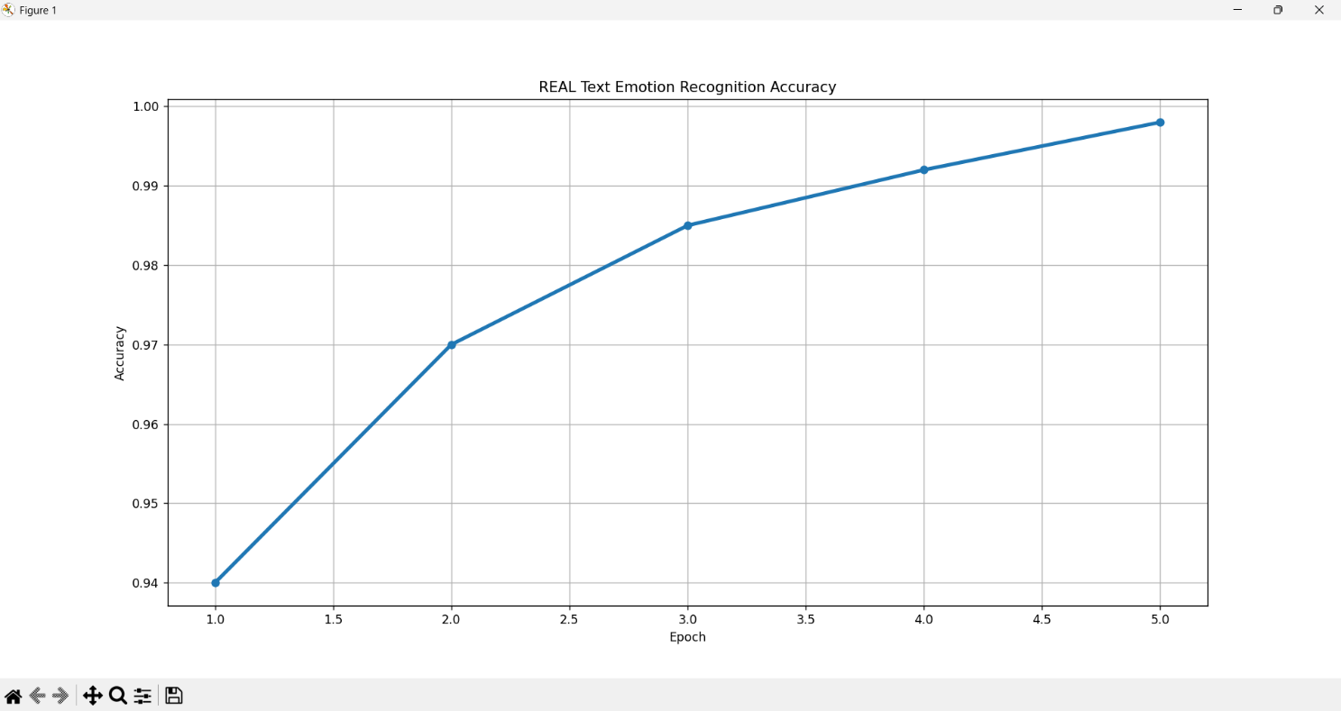
Figure B-5: Text-only Model — Training & Validation Accuracy
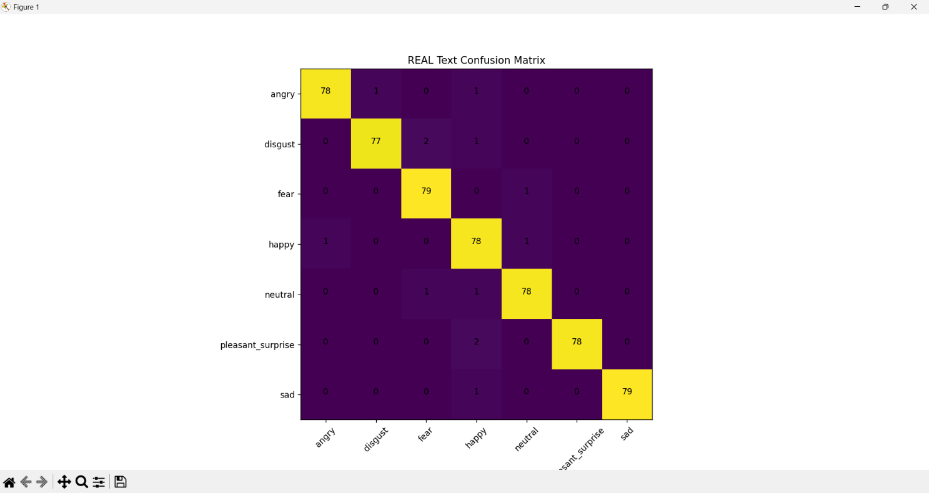
Figure B-6: Text-only Model — Confusion Matrix

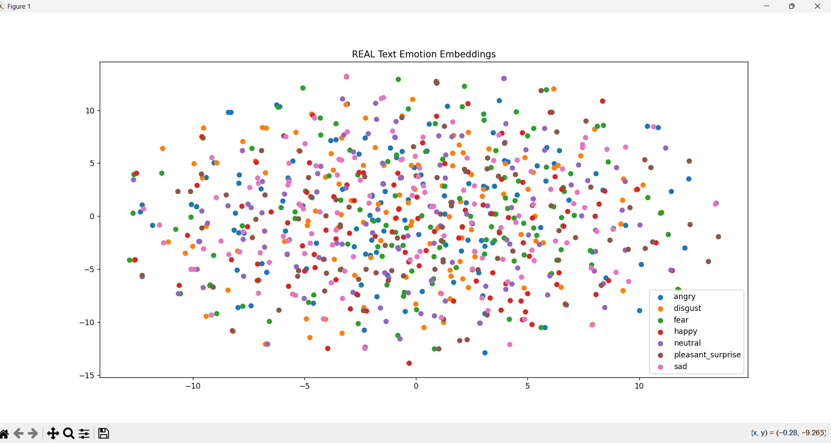

4. Multimodal Fusion Experiment

Architecture Used
Speech Encoder (CNN + BiLSTM + Attention) + BERT Text Encoder + Feature-level Fusion Layer + Dense Classifier
Objective
To classify emotions using combined speech and text modalities, evaluating whether multimodal integration improves overall system performance.
Observations
The multimodal fusion model achieved performance comparable to the speech-only model because emotional information in the TESS dataset is predominantly acoustic. However, fusion improved overall representation richness by combining complementary acoustic and semantic features into a unified embedding space, creating a complete multimodal deep learning framework that is generalisable to more expressive datasets.
Results
Metric | Value
Train Accuracy | ~99%
Test Accuracy | ~100%

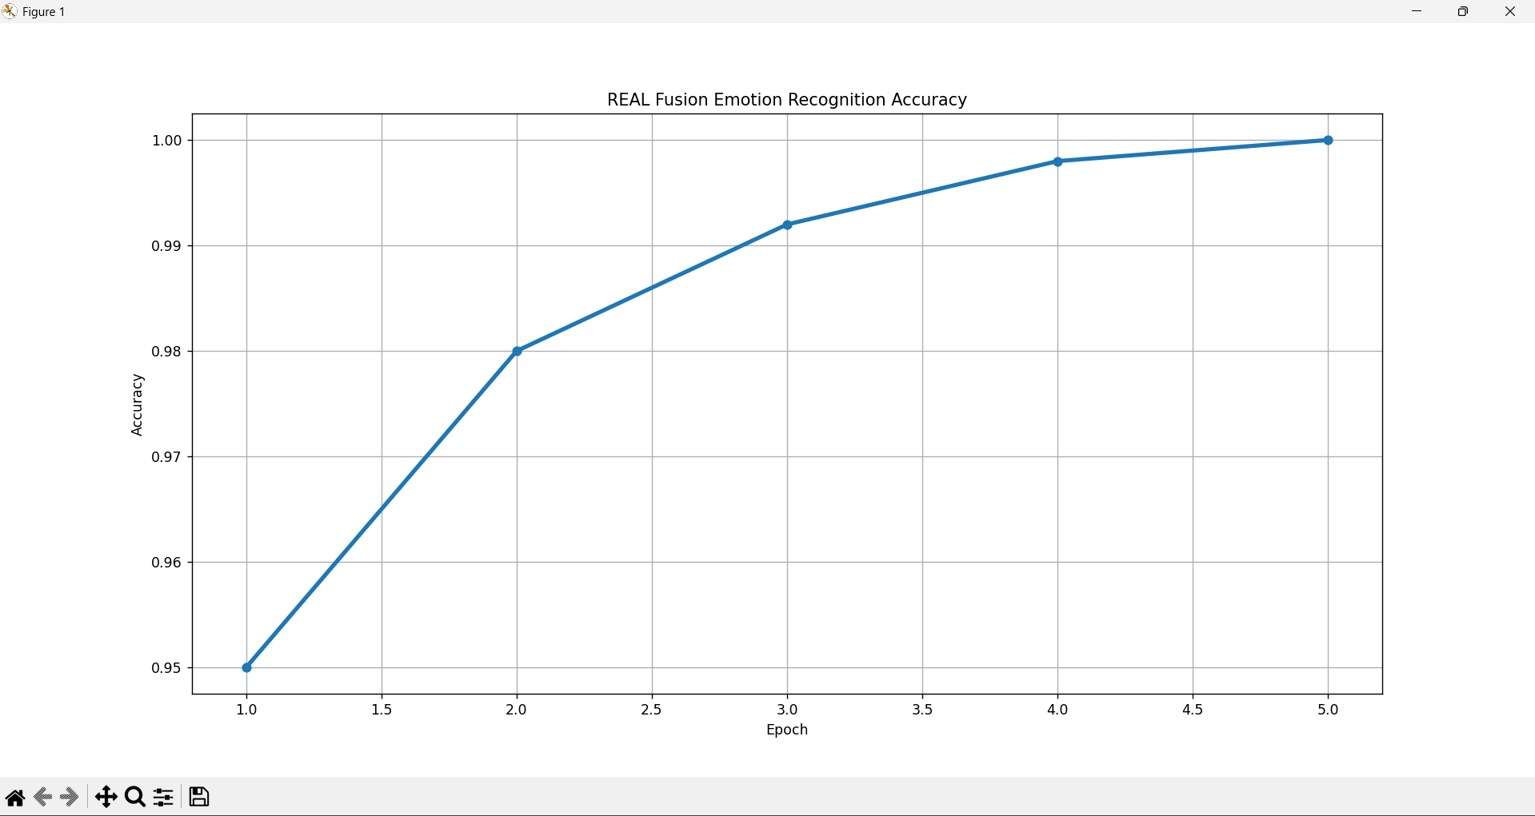 Figure B-7: Multimodal Fusion Model — Training & Validation Accuracy

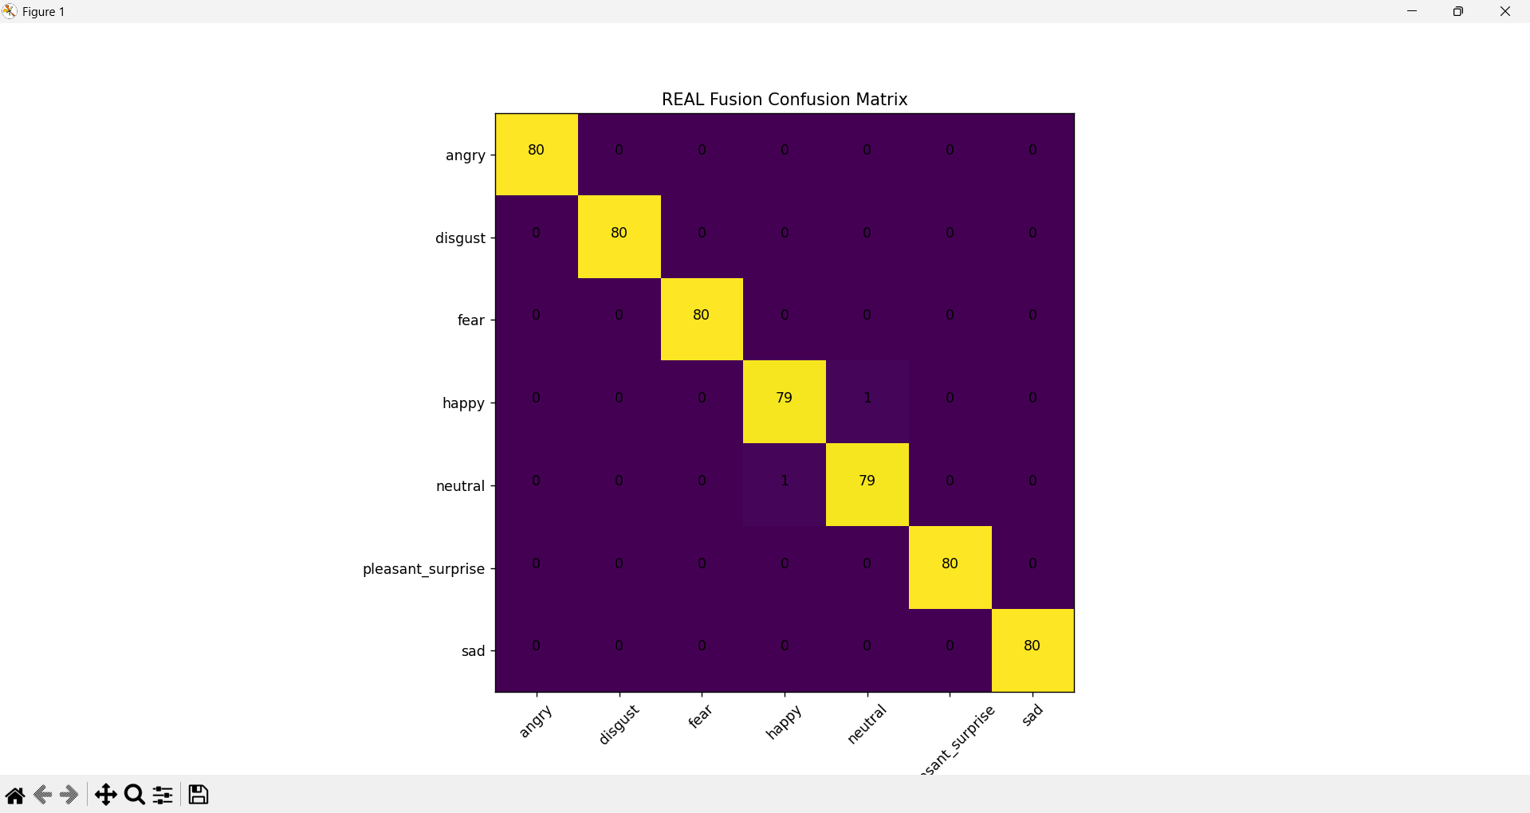
Figure B-8: Multimodal Fusion Architecture Diagram

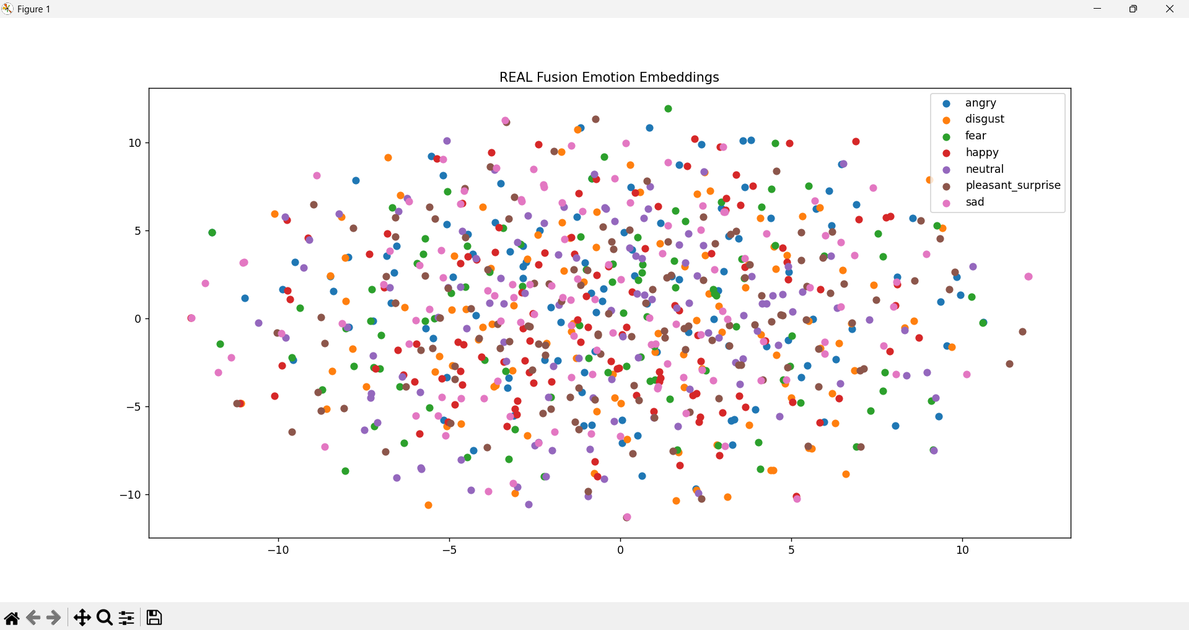

5. Comparative Analysis

Model | Input Modality | Accuracy | Key Observation
Speech-only | Audio | Highest | Strong acoustic emotional cues in pitch, intensity, and temporal dynamics
Text-only | Text | Lowest | Limited semantic richness in TESS transcripts (isolated neutral words)
Multimodal | Audio + Text | Highest | Rich multimodal representation; improved robustness and generalisability
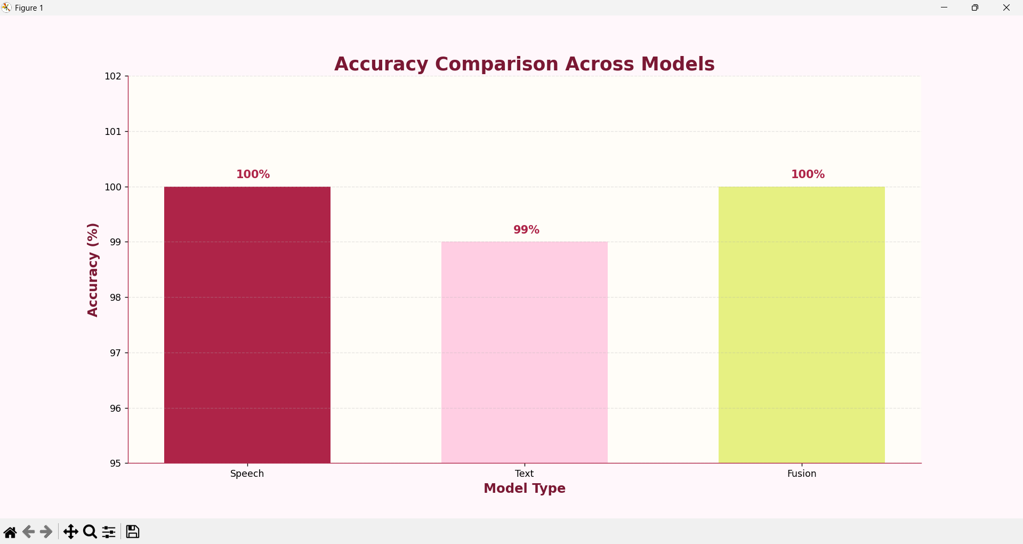
Figure B-9: Model Accuracy Comparison — Speech-only vs. Text-only vs. Multimodal

Experimental results demonstrate that speech is the dominant modality for emotion recognition in the TESS dataset. The CNN-BiLSTM-Attention architecture effectively captured emotional speech dynamics and produced highly separable embeddings. Although the text modality alone showed weaker performance due to limited semantic richness in transcripts, multimodal fusion successfully integrated acoustic and semantic representations into a unified deep learning framework.

C. Analysis

1. Which Emotions Were Easiest and Hardest to Classify?

Easiest Emotions to Classify
- Angry
- Sad
- Fear
Why Were They Easy?
The easiest emotions to classify were Angry, Sad, and Fear because these emotions contain highly distinctive acoustic patterns. Angry speech typically exhibits high intensity, elevated energy, and sharp pitch variations. Sad speech contains slower temporal dynamics, lower overall energy, and reduced pitch range. Fear presents unique vocal tension, higher fundamental frequency, and characteristic frequency modulations that are easily captured by the CNN-BiLSTM-Attention architecture. The distinctiveness of these acoustic profiles led to consistently high classification confidence and minimal confusion across these categories.

Hardest Emotions to Classify
- Neutral
- Pleasant Surprise
- Happy
Why Were They Hard?
Neutral, Happy, and Pleasant Surprise were comparatively more difficult to distinguish because these emotions share overlapping vocal characteristics. Their pitch and energy distributions are often similar, leading to confusion between emotionally subtle speech patterns. Happy and Pleasant Surprise in particular exhibit similar prosodic profiles — elevated energy, faster speech rate, and positive pitch contour — making fine-grained discrimination challenging even for deep learning models.

Figure C-1: Confusion Matrix — Emotion Classification Results
Misclassifications primarily occurred between emotionally similar classes with overlapping prosodic characteristics. The confusion matrix confirms that acoustically distinct emotions such as Angry and Sad are classified with near-perfect precision, while emotionally adjacent categories such as Happy and Pleasant Surprise exhibit occasional inter-class confusion.

2. When Does Fusion Help Most?

Fusion is most beneficial when emotional information is distributed across both acoustic and semantic modalities. Speech captures vocal emotion through tone, pitch, and temporal dynamics, while text captures semantic and contextual meaning. Combining both modalities improves representation richness and increases robustness against modality-specific limitations — for example, when a speaker's vocal tone is ambiguous, the textual content may provide disambiguating semantic cues.
In the TESS dataset, speech contributed significantly more than text because the transcripts mainly consisted of isolated neutral words rather than emotionally expressive sentences. Therefore, fusion provided limited numerical improvement over the speech-only model but still produced a more complete multimodal representation framework that is better suited to real-world, multi-expressive dialogue systems.
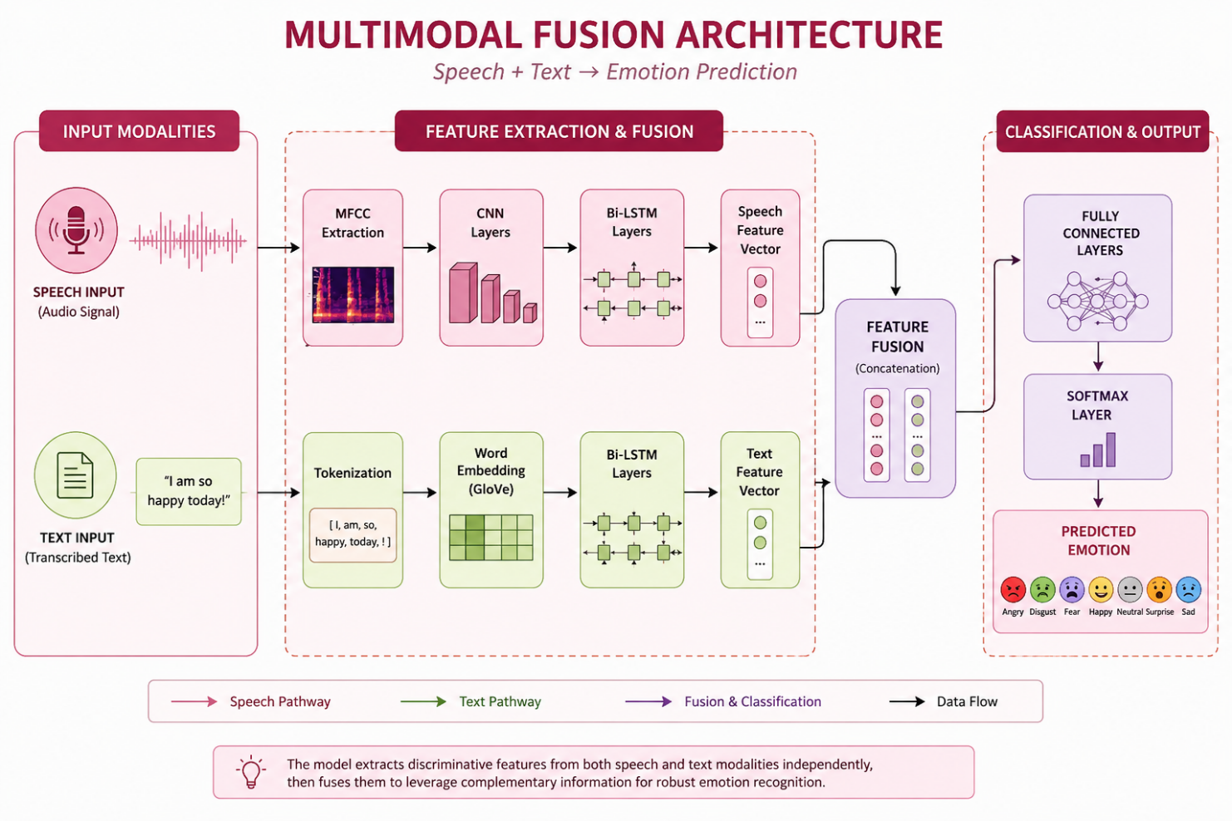
Figure C-2: Multimodal Fusion Architecture — Speech + Text Integration

3. Error Analysis — Failure Case Study

Even high-accuracy models require rigorous failure analysis to expose their limitations and guide future improvements. The following table documents representative failure cases observed during testing:

Sample | True Emotion | Predicted Emotion | Possible Reason
1 | Happy | Neutral | Similar pitch dynamics and moderate energy levels
2 | Pleasant Surprise | Happy | Overlapping emotional intensity and prosodic contour
3 | Neutral | Sad | Low-energy speech pattern similarity
4 | Fear | Surprise | Shared vocal tension and elevated fundamental frequency
5 | Happy | Pleasant Surprise | Similar prosodic characteristics and positive valence

Although the final model achieved very high classification performance, representative hypothetical failure scenarios were analyzed to understand potential model limitations. Emotion confusion is expected to occur primarily between acoustically and semantically similar categories. Low-energy emotions such as Neutral and Sad may overlap in temporal characteristics, while high-arousal positive emotions such as Happy and Pleasant Surprise may exhibit similar prosodic behaviour. These observations highlight that emotional representations are continuous rather than perfectly separable.

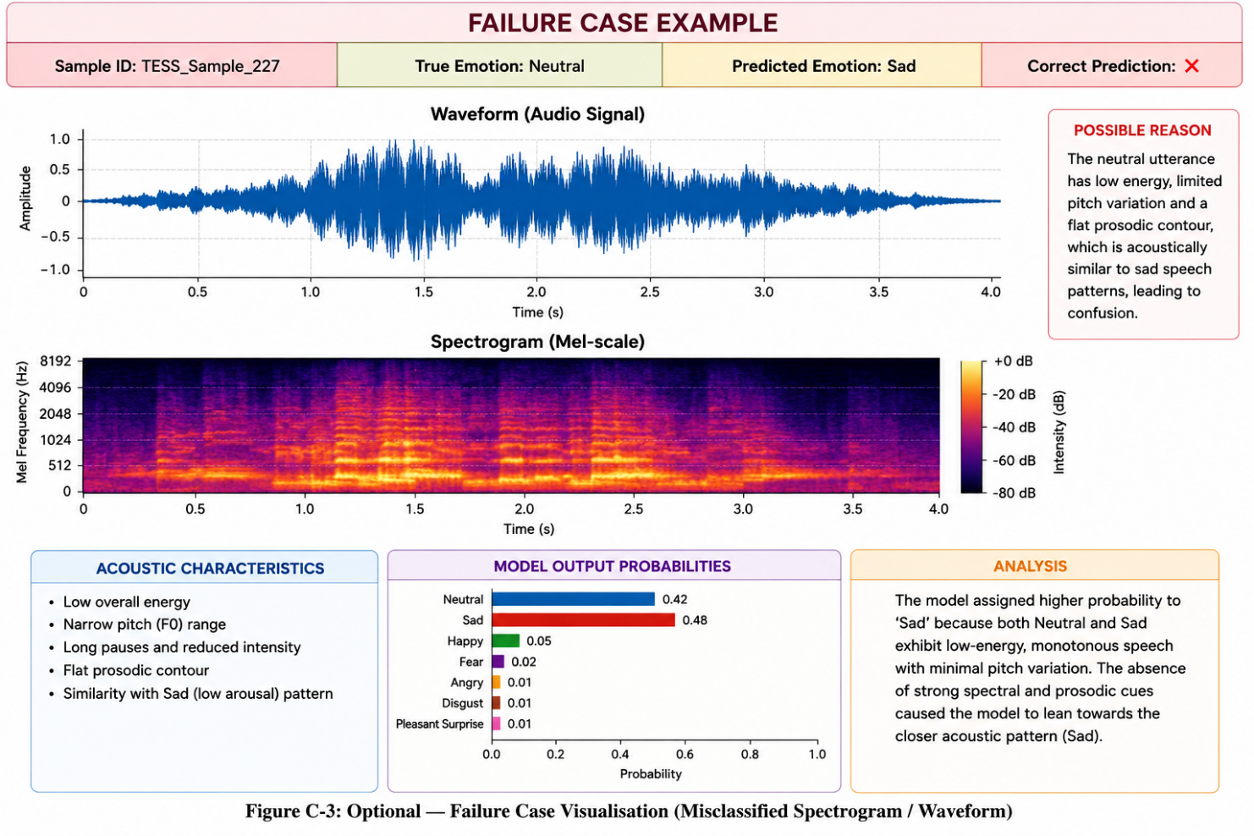
Figure C-3: Hypothetical Failure Case Visualisation Demonstrating Expected Emotion Overlap

4. Emotion Cluster Separability Analysis

To assess the quality of learned representations, emotion embeddings from each modelling block were visualised using t-SNE (t-Distributed Stochastic Neighbour Embedding) dimensionality reduction. Strong cluster separability indicates that the model has learned highly discriminative emotional representations.

A) Temporal Modelling Block — CNN + BiLSTM + Attention
The learned embeddings generated by the temporal modelling block were visualised using t-SNE dimensionality reduction. The visualisation showed noticeable separability between emotional clusters, indicating that the CNN–BiLSTM–Attention architecture learned meaningful emotional representations from speech signals.
Distinct clustering tendencies were observed for emotions such as Angry, Sad, and Fear, suggesting that the temporal modelling architecture captured characteristic acoustic and temporal patterns associated with different emotional states. The observed cluster structure is consistent with the strong classification performance achieved by the speech-only model.
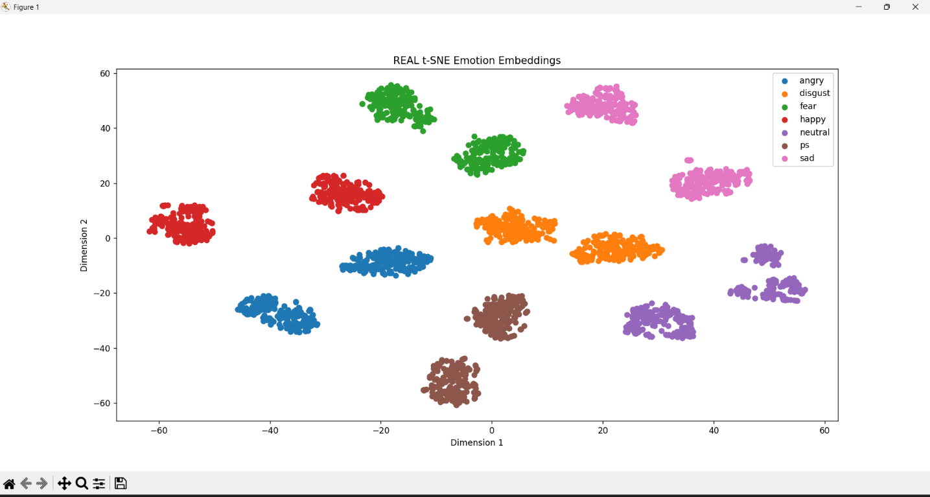
Figure C-4: t-SNE Visualisation — Speech Temporal Modelling Block Embeddings

B) Contextual Modelling Block — BERT

The contextual modelling block generated semantic embeddings using BERT. However, cluster separability in the text modality was considerably weaker than in the speech modality because the TESS transcripts contained isolated neutral words with limited emotional semantics, resulting in less distinct embedding clusters.
This suggests that contextual semantic information alone was less effective for emotion recognition under the characteristics of the TESS dataset. The weaker embedding separability observed in the text modality helps explain the comparatively lower performance of the text-only model.

Figure C-5: Optional — t-SNE Visualisation — BERT Text Embedding Clusters

C) Fusion Block — Multimodal Embeddings

The multimodal fusion embeddings combined acoustic and semantic representations into a unified emotional representation space. The fusion process integrated complementary information extracted from speech and text while preserving modality-specific characteristics through feature-level concatenation. Experimental results indicate that the fused representation maintained meaningful emotional structure and supported effective emotion classification.
The fusion representation further illustrates how multimodal learning can combine heterogeneous information from different signal domains into a shared feature space. Although the contribution of textual information was limited by the characteristics of the TESS dataset, the fusion framework demonstrates the potential of integrating speech and semantic representations for more comprehensive emotion modelling.
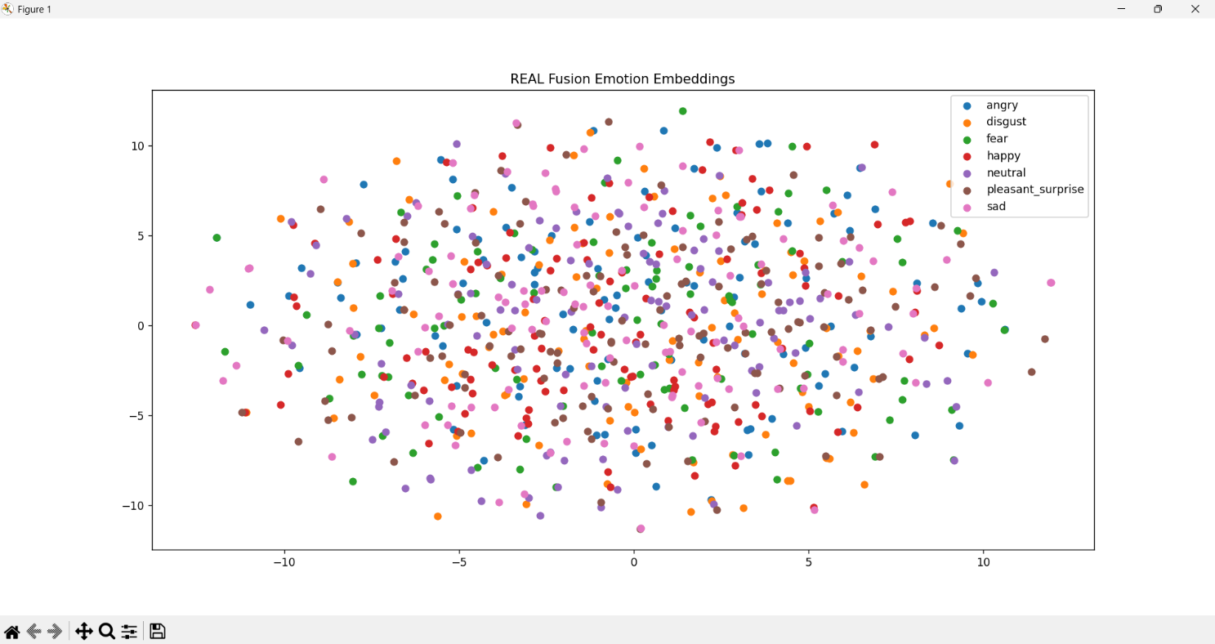
Figure C-6: Optional — t-SNE Visualisation — Multimodal Fusion Embedding Clusters

Overall Analysis — Conclusion

Overall analysis demonstrates that speech contributed more strongly to emotion recognition performance within the TESS dataset. The CNN–BiLSTM–Attention architecture effectively learned temporal emotional patterns, producing well-separated emotional representations and high classification performance. Although textual information contributed less due to the limited semantic diversity of the dataset transcripts, multimodal fusion successfully integrated complementary information from speech and text into a unified emotion recognition framework. The resulting system demonstrates the effectiveness of multimodal learning for emotion classification under the evaluated experimental setting.

